**Workspace User Manual**

**Table of Contents**

* **What is Workspace**
* **How to Run:**
* **Login/Register**
* **Notepad**
* **Editing the Notepad**
* **Bold/Underline/Italic**
* **Font Style and Size**
* **Text Color**
* **Text Alignment**
* **Cut,copy,paste,clear**
* **Find and Replace**
* **View**
* **Theme**
* **Encryption/Decryption**
* **Paint**
* **Journal**

# What is Workspace

Workspace is a smart 3 in one Desktop Application built using Python..Thinking why it is called ‘Smart’, it’s because you can create , edit and paint at one place. Workspace also allows you to do a lot of new things . These include:

* Login/Register:You can store all your documents and other related work at one place i.e. your account. With Workspace , you can easily create an account for free and store all your things at one place.
* Encryption/Decryption : Want to keep your work private? Workspace allows you to easily do that with the Encryption feature. You can secure your work with passwords to restrict access.
* Paint : With the Paint feature of Workspace , you can easily store diagrams and edit them.
* Journal: Often we want to keep a track of our tasks, so there comes the use of the Journal application.You can easily maintain a record of your tasks, add new tasks, delete some and keep them private also as they are logged in your account only.

# 

# How to Run:

**Installations:**

Along with python, make sure you install following libraries for all functionalities of the project to run-

1. Run the following command on cmd to install pycrptodomex on your pc. This is used for encrypting and decrypting your file content in Notepad Application as it gives us access to an implementation of AES-256 (algorithm used for encryption and decryption).

pip3 install pycryptodomex

1. Run the following command on cmd to install pillow in your pc. This is important in order to run Paint Application:

pip install pillow

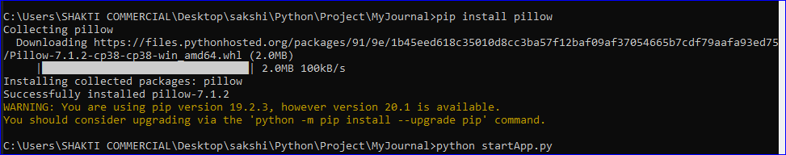

1. In order to be able to save files of Paint Application in .png format. Install Ghostscript in your system. The details of installation are given in the “Paint” section.

**Steps to download and the project from git repository:**

1. Open git Bash in the directory of your PC in which you wish to download the project. This can be done by right clicking in the directory and selecting “Git Bash Here” (Make sure you have git installed in your pc).

Alternatively, you can also run the same commands on the command prompt(cmd) to download the project in the concerned director provided you have git installed in your PC.

1. Go to the url: <https://github.com/sakship31/Workspace>
2. Copy the https url given under “clone or download” option when you open above url on browser.

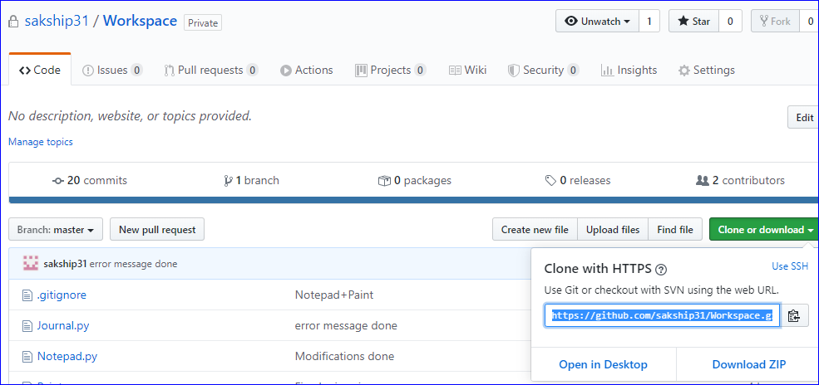

1. Go to Git Bash or command prompt and run the following command and paste the copied url and press enter:

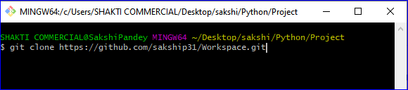

This will download the project in the given directory

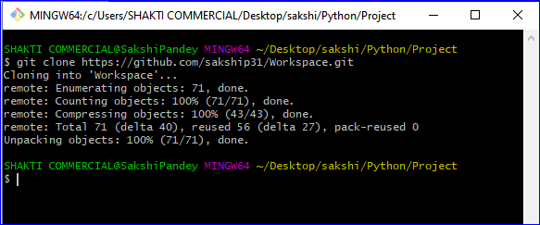

1. To run the project, go to MyJournal directory in command prompt and give the following command:

python startApp.py

Press Enter

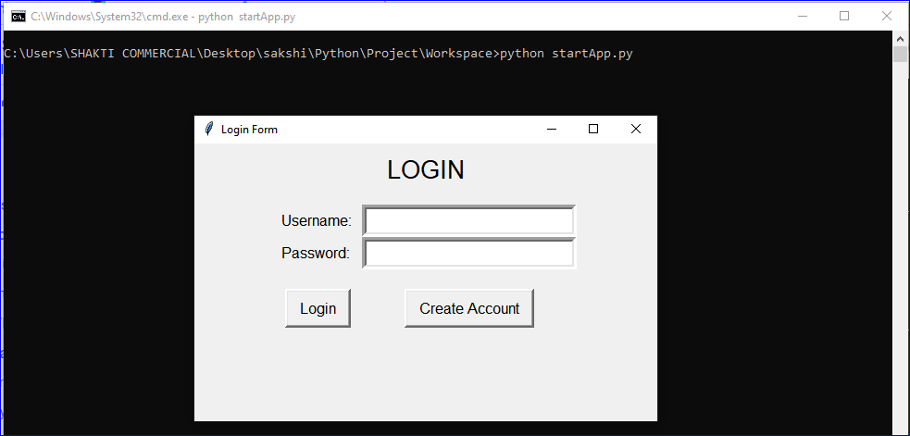

# Login/Register

Before using the various functionalities offered by TexEd, you need to create an account. Every time you will use Workspace , you will be prompted to enter your Login Credentials.This feature makes your work more secure and protected.

When you run the Python File StartApp.py, you will get the following window:

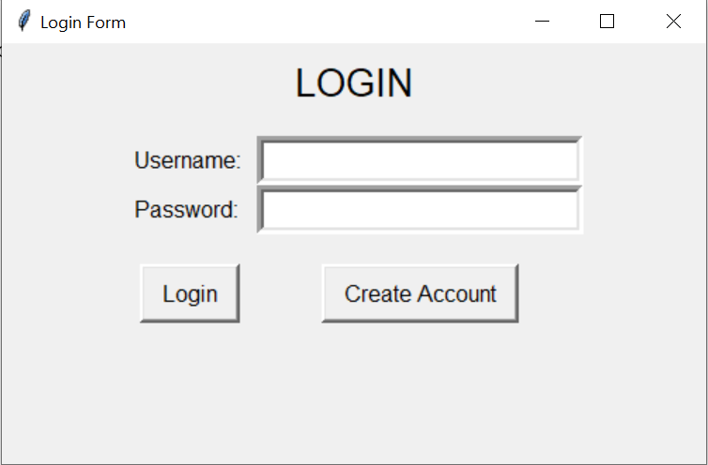

If you have not created an account yet, you need to register first:

To Register:

1. Click ‘Create Account’ Button.
2. Enter the Username and Password.
3. Click ‘Create Account’ Button.
4. You will get the message ‘Account Created Successfully’.
5. Then you will Redirected to the Login Form.

To Login:

1. Enter your Username and Password.
2. Click on the ‘Login’ button.
3. After successful login, you will be redirected to the main page.

Click on the image below to view the video for any help.

[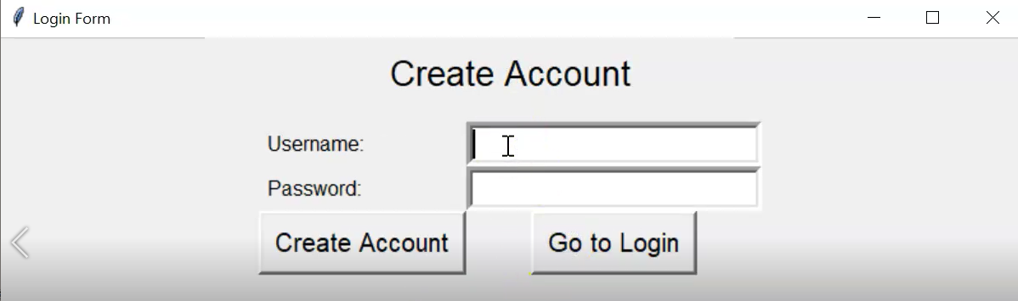](https://drive.google.com/file/d/1hvIpO8FooxRy2idMdy89eHPtetmuUMtC/view?ths=true)

After a successful login you will be directed to the, Home Page where You can select any option.

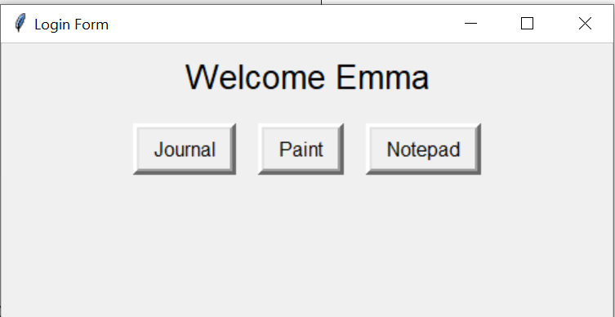

# 

# 

# 

# Notepad

When you click on the Notepad option, you will get the following screen:

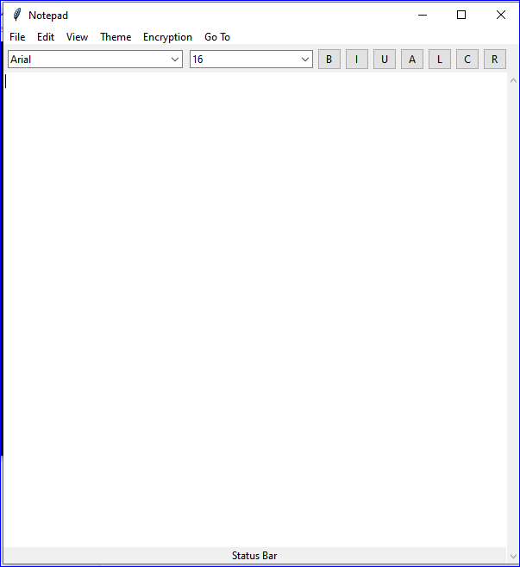

Status bar:

It gives the word and character count.

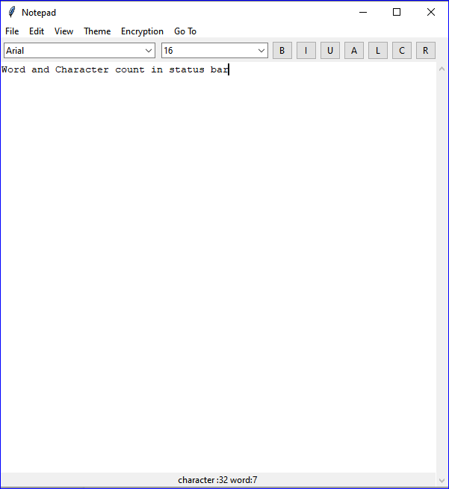

Creating New File:

1. Click the ‘File’ option in the menu bar.
2. Click on ‘New’.

Saving File:

1. Click the ‘File’ option in the menu bar.
2. Click on ‘Save’ to save the file to your desired location.

Opening File:

1. Click the ‘File’ option in the menu bar.
2. Click on ‘Open’ to open the file from your desired location.

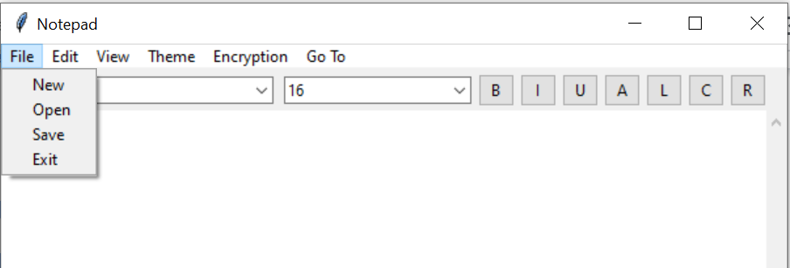

**Editing Options**

1.**Bold/UnderLine/Italic**: To format the text of your document to make it **Bold,** *Italicise*, or Underline , Select your text and click the

B : B button for Bold

I : I button for Italic

U: U button for Underline

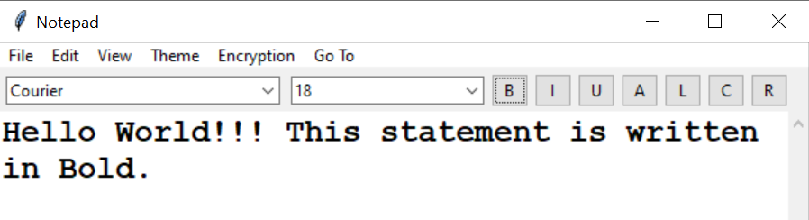

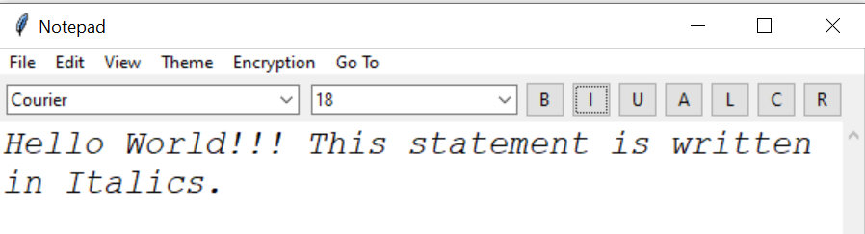

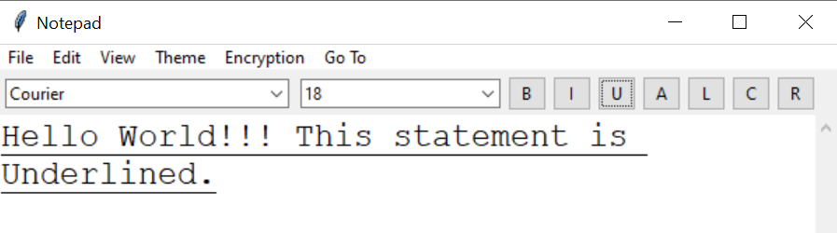

2**.Font Style and Size:** Workspace also allows you to change the font style and font size of your text document.To do this,

* Select your text.
* Click on the Arrow sign of Font Style Tab to view different Fonts.
* Click on the desired font to see the changes.
* To change the font size, click on the arrow sign of font size tab and select your desired number to see the change.

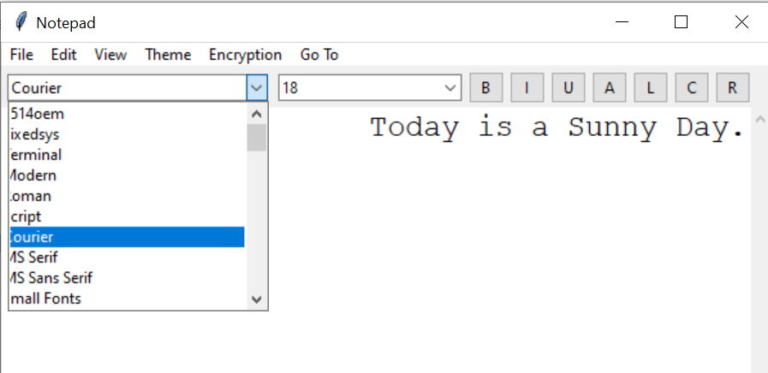

3.**Text Color** : With the help of Workspace, you can also change the color of your text. To do this,

* Click on the ‘A’ button present in the toolbar.
* A new ‘Color’ window will open.
* Select the color of your choice and click on Ok.

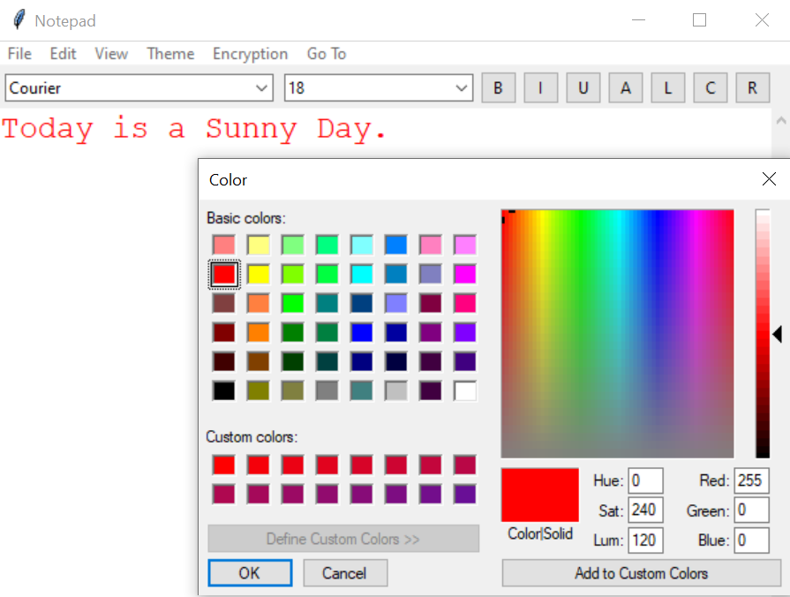

Note : You can also create Custom Colors by scrolling the color bar and then adding your desired color to Custom Colors.

Note : Default Color is Black.

4. **Text Alignment**: To align your text at various positions,

* Select ‘L’ from the toolbar to left align.

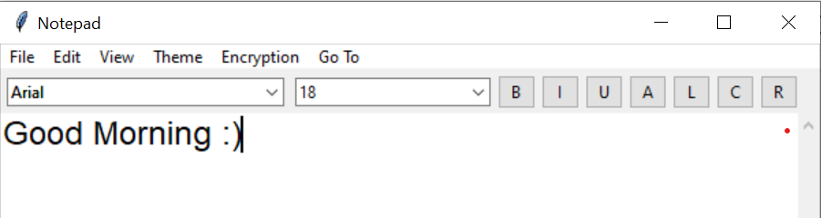

* Select ‘R’ from the toolbar to right align.

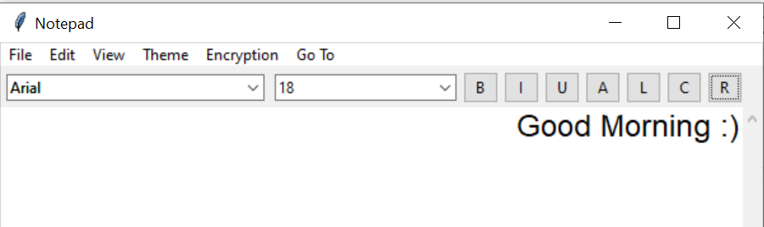

* Select ‘C’ from the toolbar to center align.

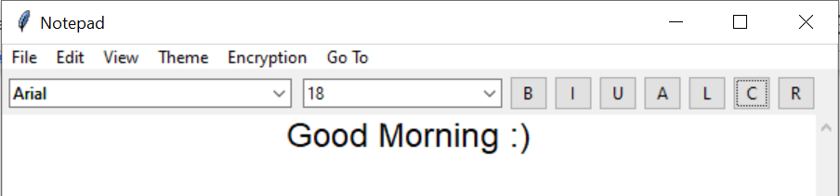

Note: Default Align is Left Align.

6.**Cut,copy,paste,clear :** Workspace also allows you to perform basic operations like Cut, Copy,Paste and Clear unlike other text editors.To perform these either use keyboard commands like Ctrl+X , Ctrl+C, Ctrl+V or go to the edit option in the Menu Bar.

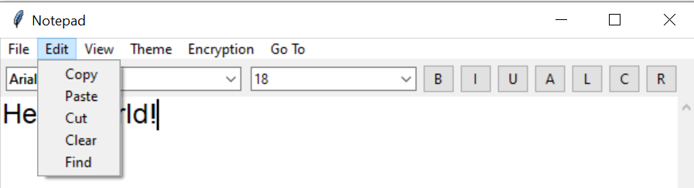

7. **Find and Replace**: Often while writing very long documents, if we want to replace some words or search a particular word, it becomes quite difficult to go through each and every line of the document. To solve this problem, Workspace provides you with a Find and Replace option.Thus you can easily find or replace words. To use it:

* Click the Edit option present in the menu bar.
* Select the Find option.
* A new ‘Find and Replace’ window will open.

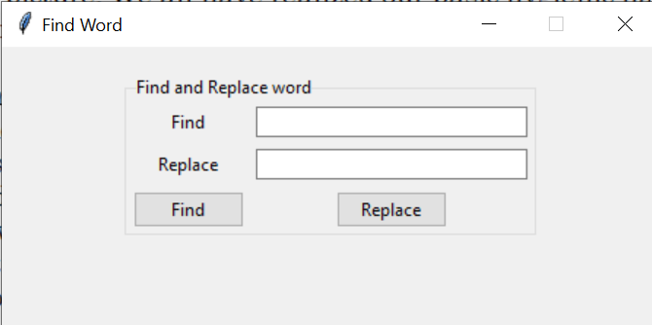

* To find a word, enter the word in the Find textbox and click on Find.

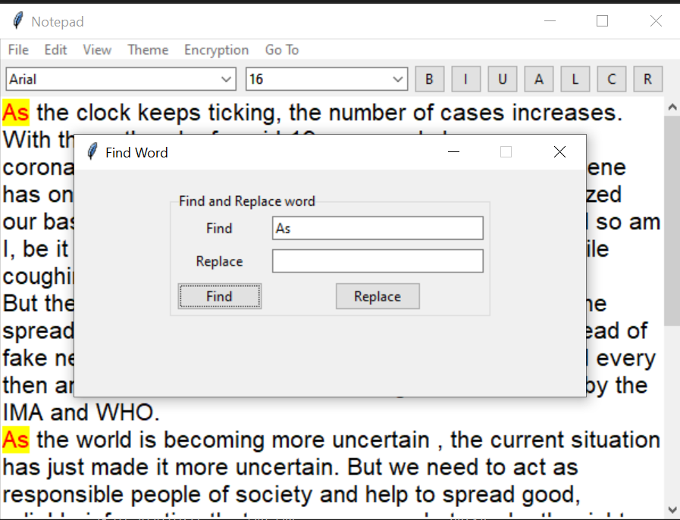

* To replace an existing word with a new word, enter the original word in Find textbox, the new word in Replace textbox and click on Replace.

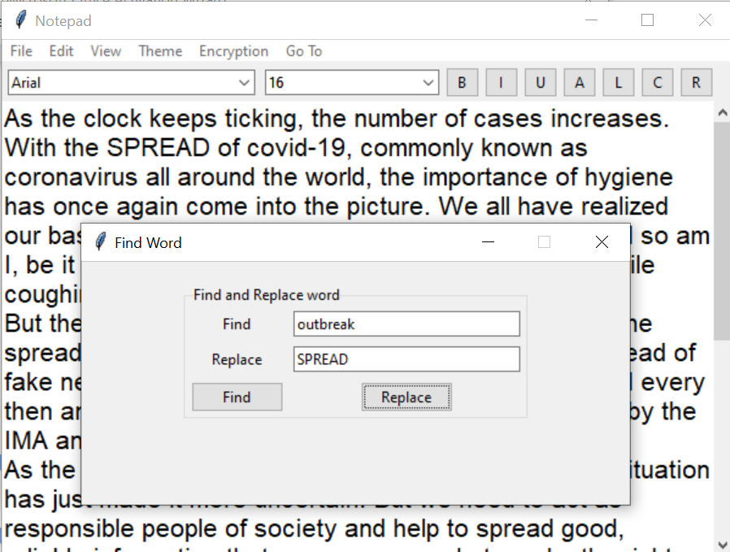

8. **View :** With the help of the View toolbar , you can choose which menubar you want to view or not.

9.**Theme :** Some like it bright , Some like it Dark. Workspace also allows you to change your workspace to Dark or Light Mode.

* Click on Theme Option in the Menu bar
* Select your desired theme.

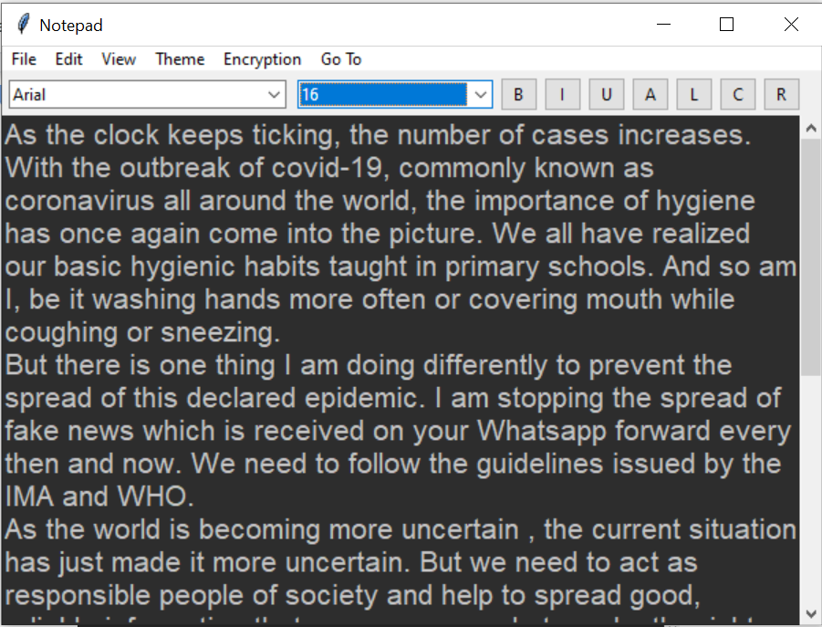

Note: By default, Light theme is selected.

10. **Go To:** With the help of the Go To option present on the menu bar , you can switch between applications. From notepad you can go to Paint as well as the Journal application.

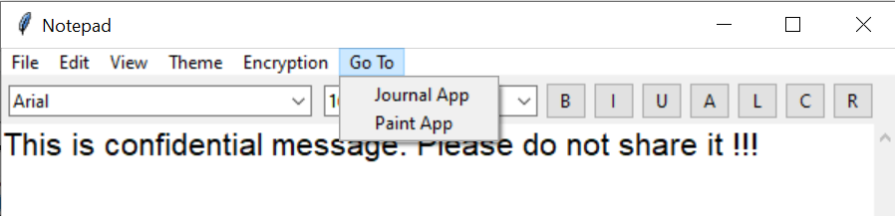

**Encryption/Decryption**

**Encryption** is the process of translating plain text data (plaintext) into something that appears to be random and meaningless (ciphertext).

**Decryption** is the process of converting ciphertext back to plaintext.

Only authorized parties can decipher a ciphertext back to plaintext and access the original information.

This option is highly useful, when you are storing sensitive data.

To Encrypt the message ,

* Click the Encryption button present on the menu bar.
* Click on Encrypt.
* You will be prompted to create a password to store the message.

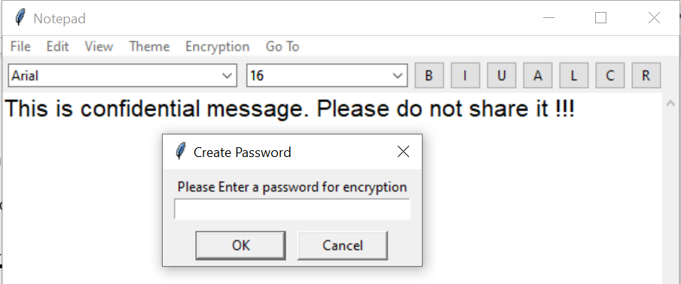

* Enter the password.

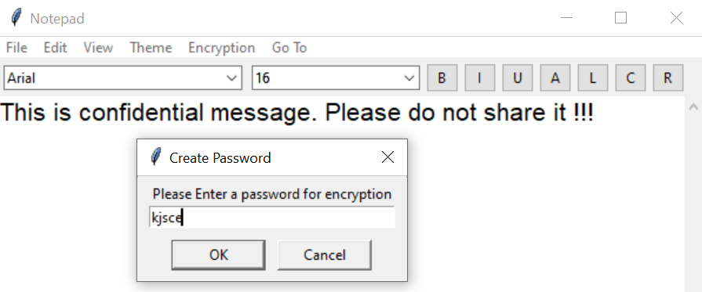

* Click on Ok.
* Your message will be encrypted.

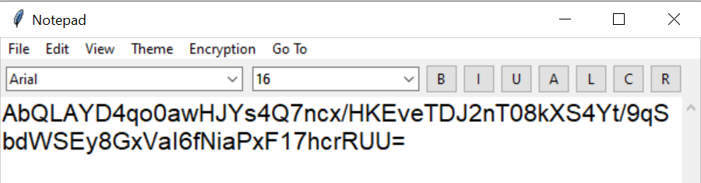

To decrypt your message,

* Click the Encryption button present on the menu bar.
* Click on Decrypt.
* You will be prompted to enter the password to decrypt the message.
* Enter your password.

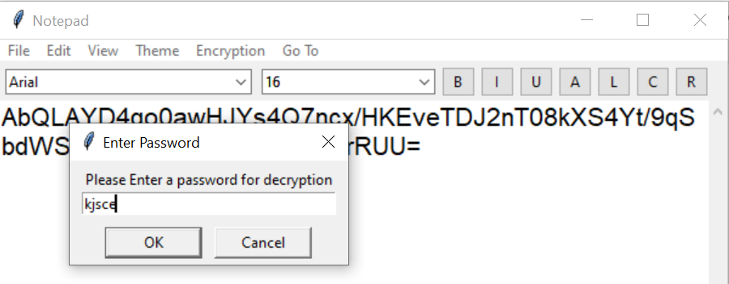

* Enter your password.
* Click on Ok.
* Your message will be decrypted.

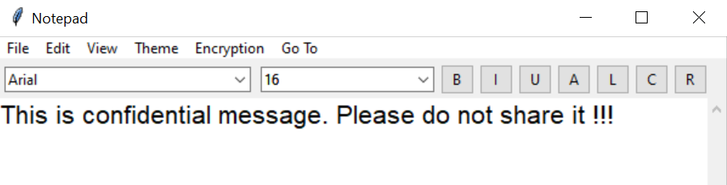

# Paint

**NOTE: In order to run paint, you must have Pillow installed in your system.**

**To install Pillow, open cmd and type in ‘pip install pillow’**

Workspace also provides you with the paint functionality. It is a simple raster graphics editor. When you will click on the Paint option after logging in, you will see the following window.

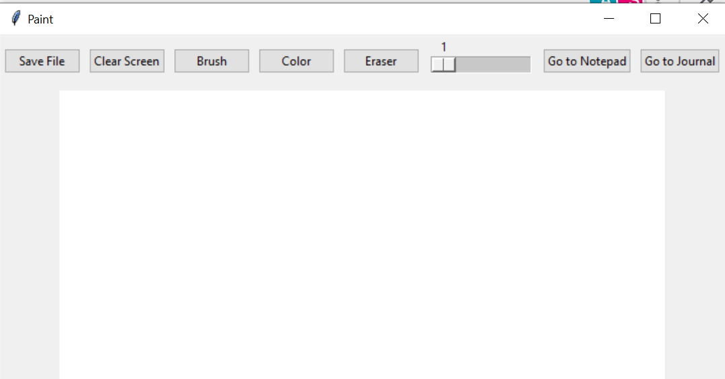

There are various options present in the toolbar. The functionalities present are:

**1. Brush :** Click on the brush option to draw using a fine tip.

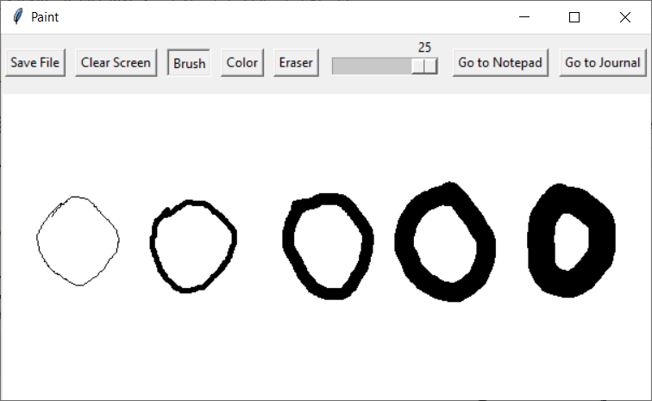

Note : You can adjust the brush size from the size scrollbar(slider) present at the top right.

**2.Color :** What is a drawing without color? To add color to your drawing click on the ‘Color’ option present in the menu bar. A new color window will open.From here you can select any color for your drawing.

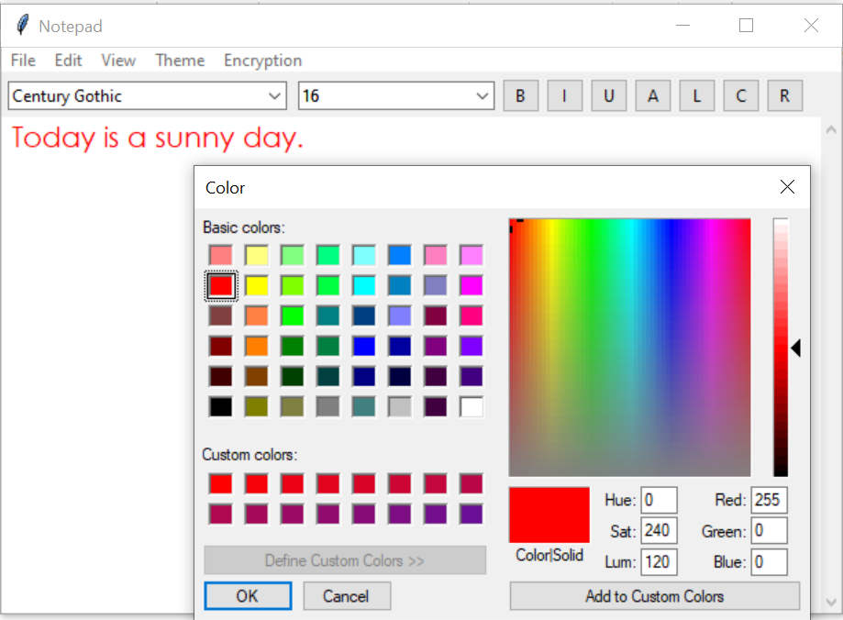

A simple colorful drawing made with paint.

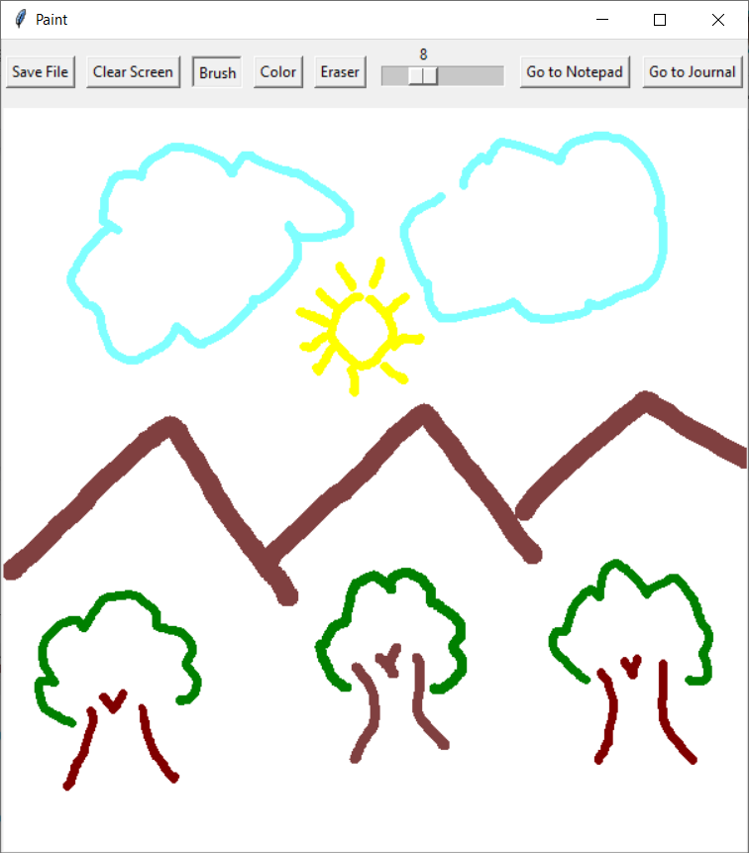

**3.Eraser:** To erase what you have drawn using the brush, click on the ‘Eraser’ option in the menu bar and erase whatever you like using the mouse cursor.

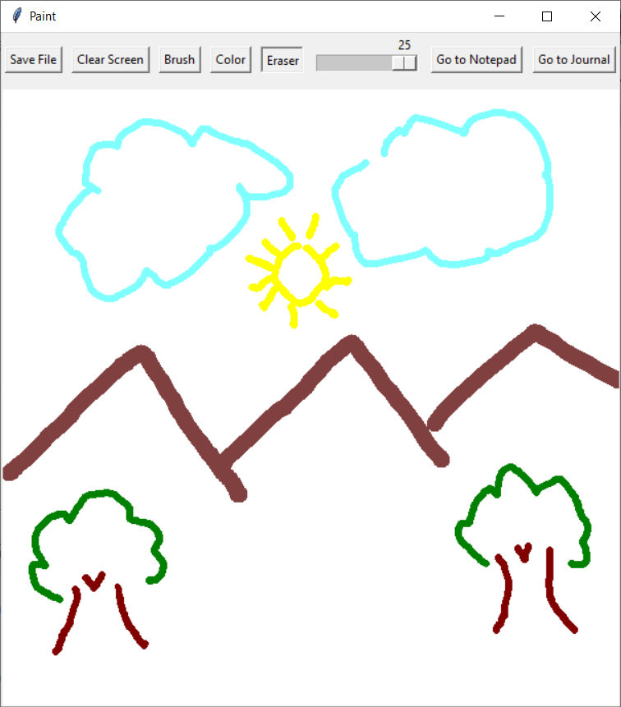

Note : You can adjust the eraser size from the size scrollbar(slider) present at the top right.

**4. Clear Screen:** You can clear all items on the drawing canvas by clicking on the ‘Clear Screen’ button.

**5. Go To Notepad:** Click on this button to redirect to the Notepad application.

**6. Go To Journal:** Click on this button to redirect to the Journal application with the currently .

**7. Save File:** You can save your drawings in the .png format by clicking the ‘Save File’ button.

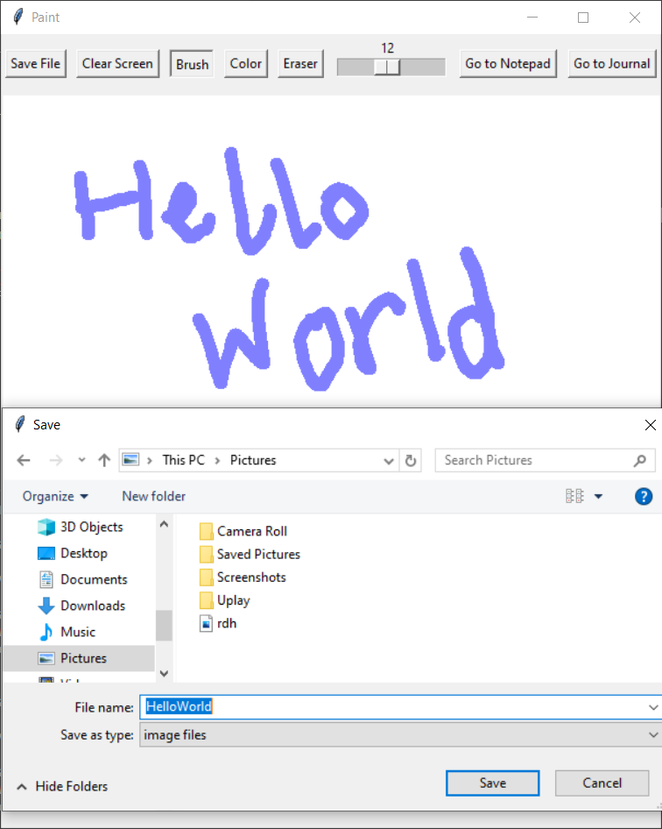

Select the directory where you wish to save your drawing, specify a name and click ‘Save’. Then, you’ll see two files in your directory, a .eps(Encapsulated PostScript File) and a .png file. In this way,you can access your drawings anytime you wish.

**NOTE: In order to be able to Save drawings as .png format images, you need to have Ghostscript downloaded and the system environment variable ‘Path’ in the control panel set to the bin folder of the folder where ghostscript has been installed. You may have to restart the system after setting the Environment Variables**

**There are two ways to download GhostScript on your system**

1. **Download it manually using the link given below (recommended)**

[**https://www.ghostscript.com/download/gsdnld.html**](https://www.ghostscript.com/download/gsdnld.html)

1. **By running the command ‘pip install ghostscript’ in cmd**

You can then view your drawings anytime you like.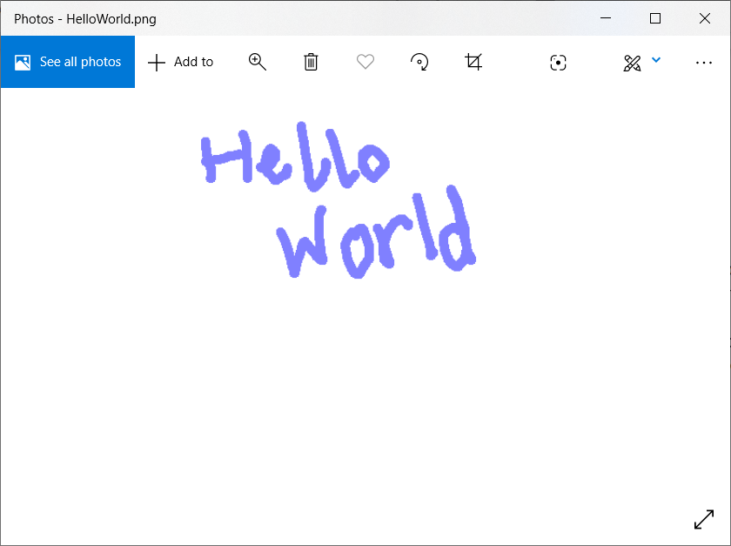

# Journal

Workspace also provides you with the Journal functionality. It is a simple journal app which keeps records of the work that you save. As the work displayed and worked on is user specific, it is log in based. In this space you can save your multiple personal works and work with the following features.

1. Click on the “Journal” button in the menu that appears after you log in.

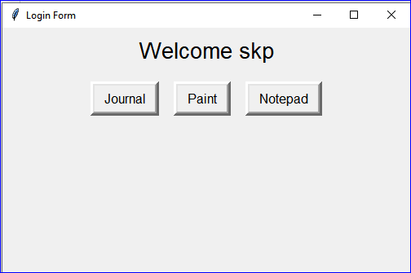

1. Your entries(login based user specific) till date will be displayed with entry number, title, content, timestamp.

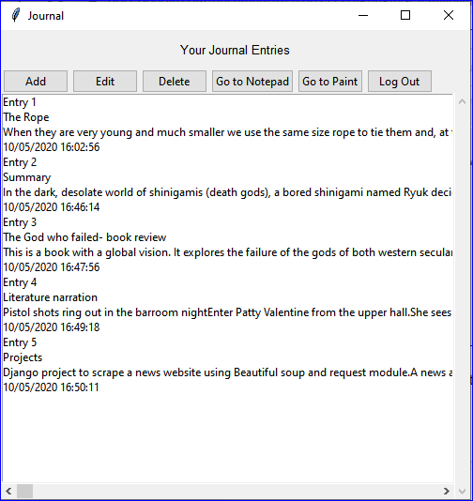

Various features in journal app are as follows:

1. **Add:**

Click on add button on top and a form window will appear for you to add title and

content

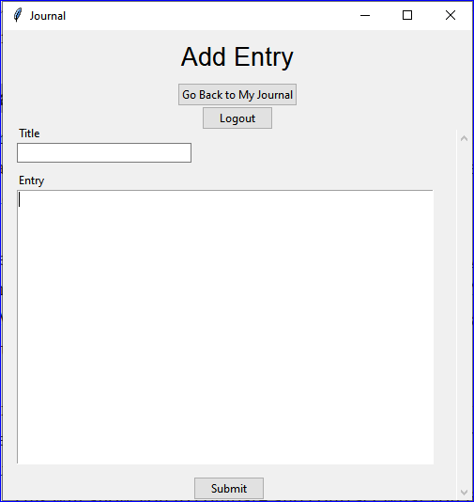

Fill the form :

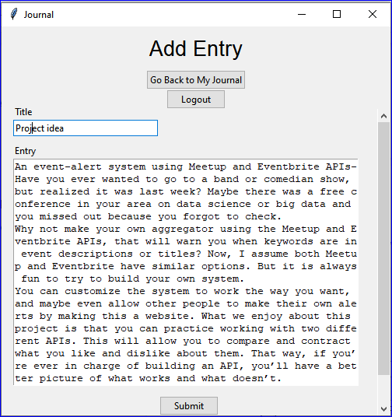

Click submit

This will redirect you to the main page with added entry at the end.

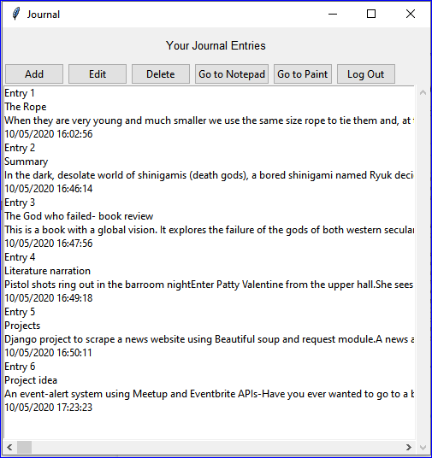

1. **Edit**

Click on the “Entry number” you would like to edit.

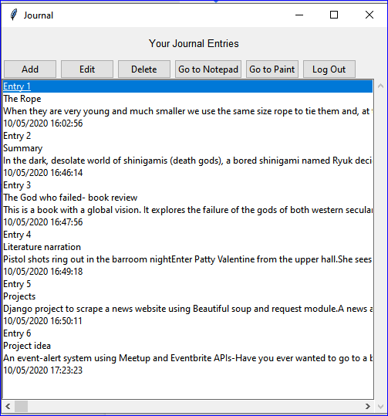

Here, Entry 1 is selected(for demonstration)

Click on “Edit” button on top, this will redirect you to a form window with current entry.

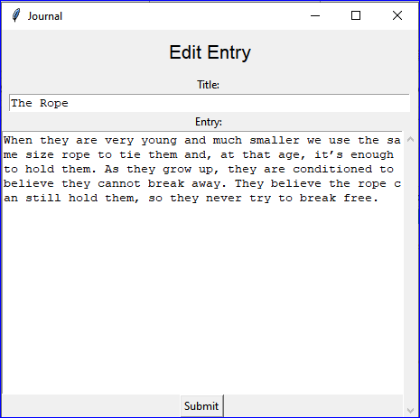

Here, you can edit the title or content

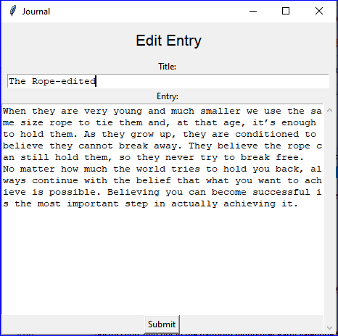

Here, the content is changed

Click submit once done and this will redirect you to the main page with edited entry.

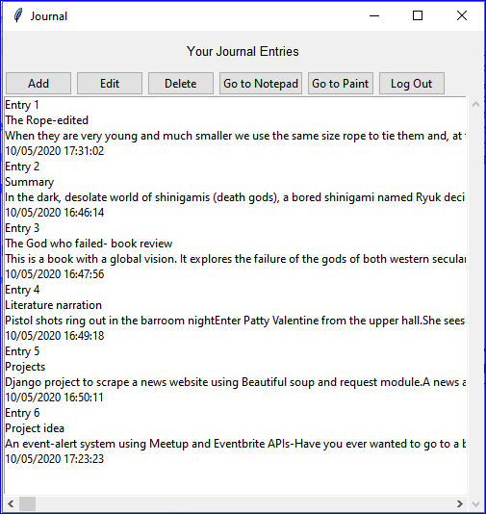

1. **Delete**

Click on the “Entry number” of the entry you would like to delete.

Then click on “Delete” button on top.This will delete the entry from the record.

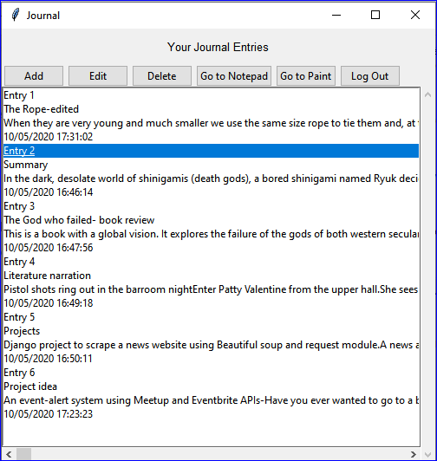

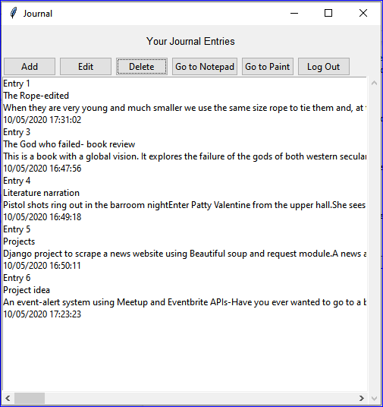

The entry numbers will be updated when you reload the app.

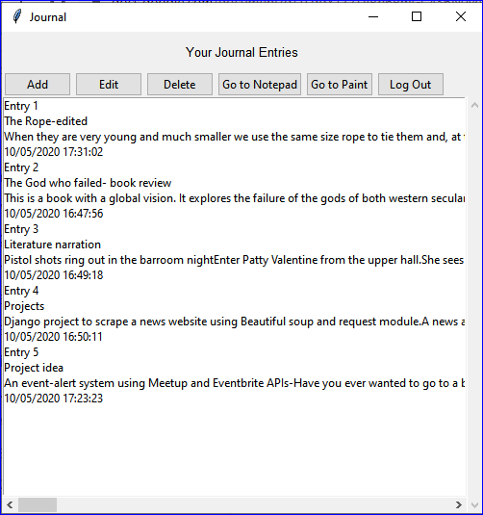

1. **Go To Notepad:** Click on this button to redirect to the Notepad application.
2. **Go To Paint:** Click on this button to redirect to the Paint application.
3. **Log Out:**

Click on this button to log out from the app. This will open the login dialog box for ou to login again or you can close the application.